**Sprint** 2 **-** Accuracy **Design Document**

November 14**, 20**22

# Executive Summary

## ***Project Overview***

This product is a robot with the capabilities of traveling across the entire endurance course in room HH208. The intended audience is the professor and students of CS-104 01.

## ***Purpose and Scope of this Specification***

Programming of robot to travel the Accuracy course in room HH208. Intended audience are the professor and students of CS 104 01.

# Product/Service Description

## ***Product Context***

The product relates to other robots, in that its sole purpose is to travel a layout course in room HH208 and help CS 104 students further understand problem solving. It is independent and self contained. It interfaces only within its own system. It programming a simple block code language in comparison to other AI robots that are being created using python mainly.

## ***User Characteristics***

* N/A, we have no customers.

## ***Assumptions***

Robots functionality would likely be overall better if it had a consistent speed.

Robot will more accurately travel the path if it stops and delays before turning likely.

Robot is less likely to skid of track if traveling at a slower speed

## ***Constraints***

* Project must be done using the Sphero robot only
* Only language allowed is block code
* Lack of actual security for the software

## ***Dependencies***

* Accuracy layout is a traversing of a figure 8 course 5 consecutive times..
* Sensor data that we must submit at the end has to resemble 5 figure eight’s.
* Project’s due date is November 15 midnight

| **Req#** | **Requirement** | **Comments** | **Priority** | **Date Rvwd** | **SME Reviewed / Approved** |
| --- | --- | --- | --- | --- | --- |
| ENDUR_01 | Must accurately circumnavigate the entire endurance course | N/A | 1 | 11/13 |  |
| ENDUR_02 | Must travel circular paths for certain distances | N/A | 1 | 11/13 |  |
| ENDUR_03 | Must be able to turn into the next circular motion without going off target. | N/A | 1 | 11/13 |  |
| ENDUR_04 | Must loop the figure 8 course 5 times. | N/A | 1 | 11/13 |  |
| ENDUR_05 | Must stop after accurately traveling the entire Accuracy course. | N/A | 1 | 11/13 |  |
| ENDUR_06 | Robot at the end of the Accuracy course must say, “I am the winner.” | N/A | 1 | 11/13 |  |
| ENDUR_07 | Robot at the end of the accuracy course must flash multicolored lights for 5 seconds. | N/A | 1 | 11/13 |  |
| ENDUR_08 | Robot must be fully designed to complete all previously stated requirements by Nov 15 | N/A | 1 | 11/13 |  |
| ENDUR_09 | Robot should travel at consistent speed throughout | N/A | 3 | 11/13 |  |

## ***Security***

### **Protection**

Lead Programmer’s Sphero account with the block code will have a complex password. Sphero will only be signed into lead programmers phone to minimize chance of access leaking. Password for lead programmers Sphero account will be changed weekly. Sphero will be recorded and looked over to ensure that its path traveled matches to sensor data, to ensure there are no errors in our data recording.

### **Authorization and Authentication**

Authorization for access to software must be obtained directly from the lead programmer. Any changes must first be checked with the lead programmer.

# Requirements Confirmation/Stakeholder sign-off

Include documentation of the approval or confirmation of the requirements here. For example:

| **Meeting Date** | **Attendees (name and role)** | **Comments** |
| --- | --- | --- |
| 11/13/22 | Azeez Olapade Lead Programmer / Tester | N/A |
| 11/13/22 | Biyi Abass Lead Data Manager / Recorder | N/A |
| 11/13/22 | Sekou Diabate Assistant Tester / Data Manager | N/A |

# System Design

## ***Algorithm***

* Program Start
* Robot will travel a 360 degree circular path over the span of 10 seconds at a speed set to 50.
* Robot will travel a -360 degree circular path over the span of 10 seconds at a speed set to 50.
* Robot will stop
* Robot will travel a 360 degree circular path over the span of 10 seconds at a speed set to 50.
* Robot will travel a -360 degree circular path over the span of 10 seconds at a speed set to 50.
* Robot will stop
* Robot will travel a 360 degree circular path over the span of 10 seconds at a speed set to 50.
* Robot will travel a -360 degree circular path over the span of 10 seconds at a speed set to 50.
* Robot will stop
* Robot will travel a 360 degree circular path over the span of 10 seconds at a speed set to 50.
* Robot will travel a -360 degree circular path over the span of 10 seconds at a speed set to 50.
* Robot will stop
* Robot will travel a 360 degree circular path over the span of 10 seconds at a speed set to 50.
* Robot will travel a -360 degree circular path over the span of 10 seconds at a speed set to 50.
* Robot will stop
* Robot will say, “I am the winner”.
* Robot will strobe different colors for 5 seconds
* Program End

## ***System Flow***

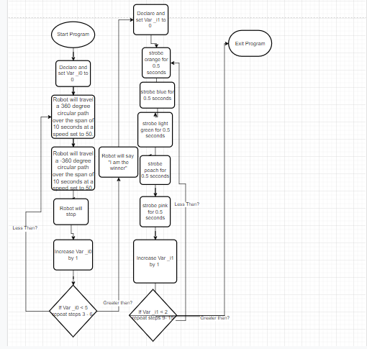

## ***Software***

The software language being used to develop this program is called block code which was originally translated from java functions. The platform this is deployed on is Sphero Edu, which is connected to our robots via bluetooth

## ***Hardware***

The hardware platform that was used is called Sphero Sprk+.

## ***Test Plan***

| **Reason for Test Case** | **Test Date** | **Expected Output** | **Observed Output** | **Staff Name** | **Pass/Fail** |
| --- | --- | --- | --- | --- | --- |
| To determine whether the robot will trace the circle at a speed of 100 over a 360 degree spin of10 seconds. | 11/14 | Yes | No | Azeez | N/A |
| To determine whether the robot will trace the circle at a speed of 100 over a 360 degree spin of 10 seconds. | 11/14 | Yes | No | Azeez/Biyi | N/A |
| To determine whether the robot will accurately turn into opposite end of figure eight if we slow the robots speed to 50 and increase time to 10 seconds | 11/14 | Yes | Yes | Azeez | N/A |

## ***Task List/Gantt Chart***

[Sprint 2 Accuracy Gantt project plan Template](https://docs.google.com/spreadsheets/d/1X3R2BmADfLtOY3kBfQzaEgzSX1MvE0FeT11tp7IK8wE/edit#gid=226517277)

## ***Staffing Plan***

| Name | Role | Responsibility | Reports To |
| --- | --- | --- | --- |
| Azeez | Lead Programmer / Tester | To develop the algorithm that the block code will follow, and to make revisions to either accordingly. Also to test the robot in order to ensure that the code was done accurately. | No one. |
| Sekou | Lead Data Manager / Recorder | To convert the algorithm into a flow chart, and also to record test data. Data manager also maintains System Design Document, and as well as that records the finished project in the robot video. Creates Github Repository. | Azeez |
| Biyi | Assistant Tester/Data Manager | Doesn’t have a task to himself mainly, but assist other group members along in their jobs, giving insight, and also suggesting his own ideas and work to main project | Azeez |